Lecture No. 14 PARASITOLOGY DR.Raad H.H.
Phylum Platyhelminthes
General characters :
- Flatworms are unsegmented, bilaterally symmetrical worms that lack a coelom (acoelomate) but that do have three germ layers.
- Some forms are free living but many are parasitic.
- Flatworms have a cephalized nervous system that consists of head ganglion, usually attached to longitudinal nerve cords that are interconnected across the body by transverse branches.
- Excretion and osmoregulation by flatworms is controlled by "flame cells" located in protonephridia (these are absent in some forms).
- Flatworms lack a respiratory or circulatory system; these functions take place by absorption through the body wall.
- Nonparasitic forms have a simple, incomplete gut; even this is lacking in many parasitic species.
- Movement in some flatworms is controlled by longitudinal, circular, and oblique layers of muscle. Others move along slime trails by the beating of epidermal cilia. The development of directional movement is correlated with cephalization. In some flatworms, the process of cephalization has included the development in the head region of light-sensitive organs called ocelli. Other sense organs found in at least some members of this group (not necessarily on the head) include chemoreceptors, balance receptors (statocysts), and receptors that sense water movement (rheoreceptors).
- Most flatworms can reproduce sexually or asexually. Most are monoecious. Most of these have developed ways of avoiding self-fertilization. Development may be direct (eggs hatch into tiny worms that resemble the adults) or indirect (with a ciliated larval form).
- Flatworms include a large number of parasitic forms, some of which are extremely damaging to animals and human populations.
- Classification :
- Class Turbellaria (turbellarians, flatworms) mostly non-parasitic.
- Class Trematoda (parasitic flukes).
- Class Cestoda (tapeworms).

'' Class Cestoda (Tape worms )''
General characters :
- Flattened dorsa –ventrally worm tape like divided to segments called proglottids ; Each proglottid is a reproductive unit.
- Hermaphrodite , flatworms containing about 5,000 species.
- Without elementary canal ; The external tissue "Tegument "; is covered totally with "Microtriches" which is similar to microvilli of vertebrate intestine that used for food absorption
& nutrition . 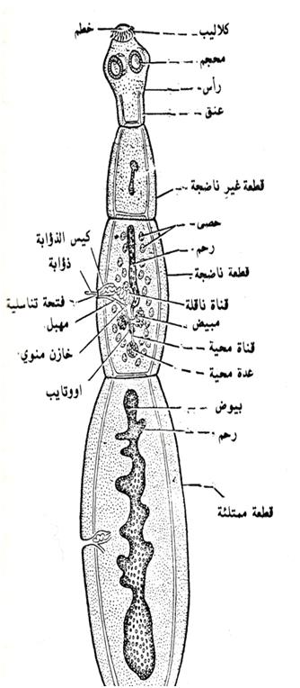
- Morphologically have :
- Scolex (head) which has the attachment organelles :
- Botheria which are Two longitudinal sucking grooves e.g. Diphylobotherium latum
- Four suckers as in Taenia .`
- Rostellum which is an a projection on Scolex fixed or retractable mostly armed with hooks as in Taenia solium ; Hymenolepis nana ; Dipylidium caninum .
- Neck : It is undivided region has the active cells for growth & proliferation from which the distal worm portion is derived.
- Strobilus :
is a structure consist of linear strand of segments ; each segment called (proglottid) & divided to :
- immature segments ; they are found in the beginning of the strand & without genital organs .
- mature segments ; they have fully developed genital organs.
- Gravid segments ; they are most distal segments & contain mature eggs in the
uterine branches ; they detached &
excreted with fecal contents e.g. Taenia solium ; or they may disintegrated inside intestine but the eggs excreted with fecal contents e.g. Hymenolepis nana .
the No. of segments { Strobilus } vary from 3 – 4 in Echinococcus granulosus to about 5000 in Taenia saginata.
- They lacking enterocole but they have paranchymatous tissue .
- Mature segments have 2 sets of female & male Genital organs reproductive system i.e. Hermaphrodite ; e.g. Taenia .
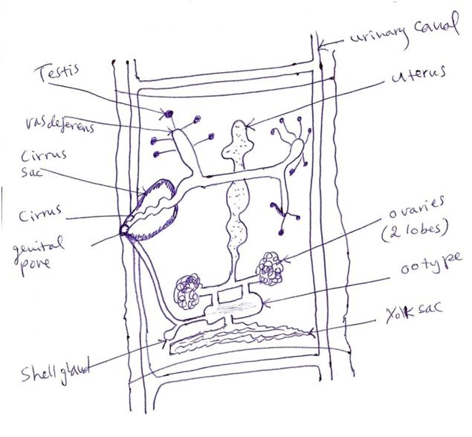

- They have simple nervous system .
- They have excretory system with Flame cells in the tissues .
- Digestive tracts are absent completely.
- Forms of Cestoda uterine :
- Uterine branches e.g. Taenia saginata.
- Par-uterine organ e.g. Avitellina
- Uterine pouches e.g. Echinoccocus granulosus .
- Egg capsule e.g. (with several eggs )Dipylidium caninum ; (one egg )Cotugnia digonopora).
- Transverse sac e.g. Hymenolepis nana ; Monezia expansa .
- Rosette – shaped coils ; it is a tube with lateral pockets e.g. Diphylobotherium latum .
10) classification of class Cestoda:

- The Larval stages of Cestoda { METACESTODES}:
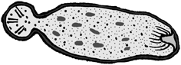
- Procercoid : it is 1st. larval stage of Diphyllobothrium (cotyloda) which is a solid organism lacking Bladder found in Arthropods e.g. Cyclops in water .

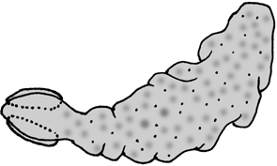
- Plerocercoid : it is 2nd. larval stage of Diphyllobothrium (cotyloda) which is a solid organism lacking Bladder found in fishes or reptiles in water .

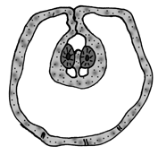
- Cysticercus : it is the larval stage which have a small size bladder with invaginated Scolex found in vertebrates intermediate host ; e.g. Taenia saginata .

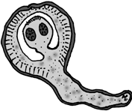
- Cysticercoids : it is a small larval stage have Scolex which enveloped by it’s tissue found in invertebrates intermediate hosts ( Beetles or Flees ) ; e.g. Hymenolepis nana ; Dipylidium caninum .

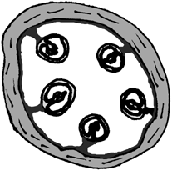

- Coneurus :
it is a large bladder with a no. of invaginated scolices found in the vertebrate intermediate host e.g. Man as in case of Taenia multicepes .
- Hydatid cyst : it is a large bladder that produce multiple internally scolices ( Protoscolex) & numerous Daughter bladders or Broad capsules found in the vertebrates intermediate host as in Man or mammals as in case of Echinococcus . types of Hydatid cyst :
- Unialveolar Hydatid cyst :
It is a large bladder contain fluid & consist of 3 layers ( 1st. fibrous ; 2nd. Non cellular laminated
; 3rd. the germinal layer cells).
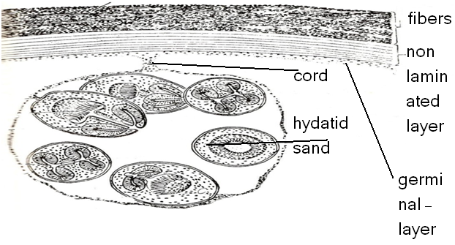
The 3rd. germinal layer produce either broad capsule which have no. of scolices inside it {Hydatid sand } or produce inside it the Daughter Hydatid cyst or the outside daughter Hydatid cyst { Exogenous daughter Hydatid cyst } ; It is found in Man & mammals as in case of Echinococcus granulosus .

- Multilocular Hydatid cyst (Alveolar): it is large bladder have scolices surrounded by gelatinous matrix divided by hyaline tissue to multicavities ; found in mouse (intermediate host) as in case of Echinococcus multilocularis (worm of fox ).
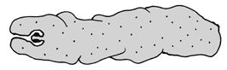
- G). tetrathyridium: it is the larval stage which have a small size bladder with one invaginated Scolex with aworm like ,solid larva found in vertebrates intermediate host ; e.g. Mesocestoides lineatus.
- Strobillocecus A larval form of Cyclophyllidean Cestodes, (e.g. Taenia taeniaeformis ).

- General Pathogenesis of adults & larvae of Cestoda :
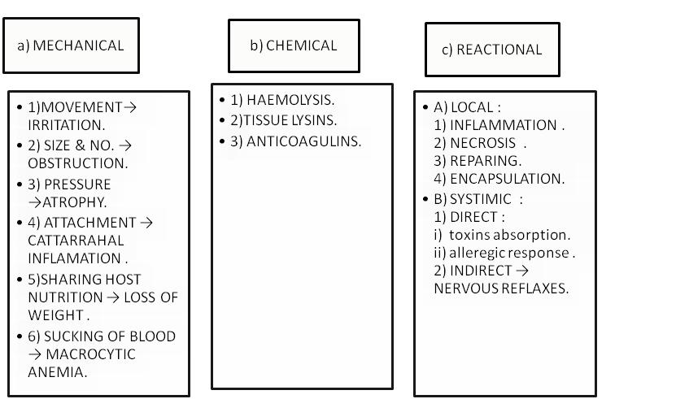

- Helminthes parasites of human includes both adults & larval Cestodes .
14) Adults Cestodes live in the intestines of the vertebrates (Man) ; while larval stages generally in the tissues or body cavity of vertebrates & invertebrates hosts.
15) All Cestodes have indirect life cycle except Hymenolepis nana .
Eggs and larval stages of cyclophyllidean and pseudophyllidean in general :
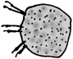 The larval cyclophyllidean, as with the pseudophyllidean, is equiped with 3 pairs of hooks. Both groups use these hooks to penetrate the gut wall of its intermediate host after being ingested, before developing into the other larval forms described above in more detail.

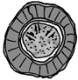 the egg of the cyclophyllideans tapeworms is very different, having a very thick, resistant egg shell, with no operculum.

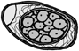 The egg of the pseudophyllidean tapeworm closely resembles that of the trematodes, having a thin shell wall, and an operculum, which on hatching opens to reseales the free swimming larvae. This illustrates the close relationship between the two major groups of platyhelminth parasites,

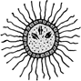 The larvae emerging from these eggs also differ. The pseudophyllidean egg hatches to release a free swimming larvae called a coracidium. This has an outer layer of ciliated epidermal cells with which it swimms through the water before being ingested by the parasites 1st intermediate host. This is often a copepod. Inside the copepod the ciliated epidermis is shed, to release a larvae that initially resembles that of the newly hatched cyclophyllideans. This has 6 hooks, arranged in pairs, and is a common feature throughout the eucestodes. On the basis of the presence of these hooks, present in both the eucestodes and cestodarians, many authors believe that the cestodes originally evolved from an ancestor common to the extant monogeneans

